1-855-372-0037
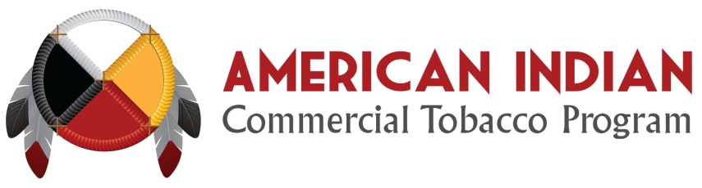

For Immediate Release
June 6th, 2016

American Indian Commercial Tobacco Program
Now Available
First of its kind commercial tobacco-cessation program designed specifically to help American Indians.

SAULT STE. MARIE, Mich. – American Indians who want to quit using commercial tobacco can call the American Indian Commercial Tobacco Program at 1-855-372-0037. The American Indian Commercial Tobacco Program is a free, newly launched service that intends to support American Indians on their journey to quit using commercial tobacco products including cigarettes, cigars, e-cigarettes, and smokeless tobacco (chewing tobacco). Administered by National Jewish Health, the program was designed by and for American Indians using culturally-sensitive coaching techniques.

Research shows that many American Indians have a strong desire to quit commercial tobacco, but have less success in quitting long-term. Support from a dedicated American Indian success coach and access to medication as needed has been linked to increased success in quitting. To meet this need, the program offers:

- Up to 10 coaching calls with a dedicated coach who is American Indian;

- 8 weeks of nicotine replacement therapy with combination medication as an option;

- Customized quit-plan with telephone counseling, emails, text messaging, and app support;

- Focus on the journey of quitting commercial tobacco, not a specific quit-date.

The American Indian Commercial Tobacco Program will gladly help callers under 18, pregnant women, elders, and members or descendants of any tribal nation. To begin your quitting journey, simply call 1-855-372-0037. A coach who is American Indian will work with you to answer a few questions and get started. This service is confidential and free of charge. Call today!
###

